Story panel
Motivation for use
With the advancements in technology and healthcare, they may need the use of computers in access to monitor their health conditions, their medical records or booking appointments. Others working within the organization may also need to access the Electronic Health Records (HER. It is also a great platform for receiving health updates.
Solution
All factors which affect readability such as text and font sizes, contrast as well as button sizes should allow ease of visibility. One of the main changes would include keeping the text and button seizes large enough for better visibility an on-screen readability. Icons are also a major change for the elderly. An easily visible text should accompany the icons to allow ease of navigation. To ensure that all the changes aimed at improving readability help in bringing the desired readability outcomes, the creation of the websites or systems should allow uses to change both the font sizes and contrast levels. This makes the system use friendly allowing them to adjust the various aspects to their comfort.
Elderly population
Most people around the age of 60 experience various inevitable cognitive and physical changes. These changes may be related to their reaction or vision abilities. The changes in cognitive and physical abilities affect the ability of the elderly to efficiently use technology, despite most of them having been around technology for long.

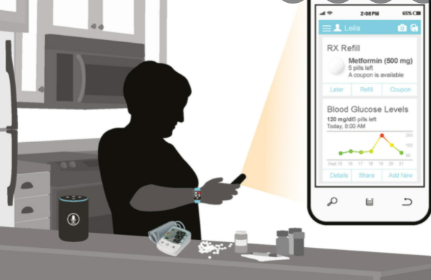

Challenges of use
Navigating the healthcare systems has been challenging for the individuals with impaired vision. The individuals may take time in understanding how to efficiently use the available technology. The use of various font sizes affects the readability of the content in the systems. The use of various shades also makes some characters appear faded. Contrast levels may sometimes not be bright enough for the individuals to easily navigate. Individuals with low reactivity may have challenges in managing notifications. Others with vision loss may find it challenging to use technology or take more time than usual in completing a certain task.

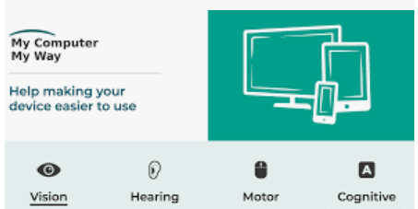
User satisfaction
Increased readability of the text increases user satisfaction.
Increased response from patients using technology.
Ability to adjust setting to user’s comfort
Increased audibility of notifications.

